THE WAGNER SOCIETY OF IRELAND
NEWSLETTER AUTUMN 2017

We hope you have had an enjoyable summer. You will find below the talks we have arranged for the 2017-18 season. Dates for 2018 are not finalized yet with the UAC.

Our opening talk should be particularly interesting. Fergus Shiel gave us a wonderful talk before conducting Tristan and he has been mandated by the Arts Council to provide mainstream opera productions in Dublin and other venues. He will talk on his vision for the future of opera in Ireland. The main topic of his talk will be the production of Robert O’Dwyer’s Eithne. The opera is regarded as one of the great lost Irish operas and is to be given in the NCH on 14th October. The opera was well received at its premiere in the Rotunda in 1909. It was strongly influenced by Wagner and Dvorak.

The Irish Opera Collective will be performing Owen Wingrave by Benjamin Britten in Limerick, Cork and Dublin in September. The young Irish baritone Benjamin Russell has been making a name for himself on the continent having sung Donner in Wiesbaden and scheduled for Wolfram in Tannhauser next season in Wiesbaden.

We hope to organize a trip to hear the Leipzig Ring Cycle in May 2018. Full details will be given later.

If you have suggestions for talks please contact any member of the committee. Your reviews of Wagner opera’s attended will be published in future editions of the newsletter. Please forward to tpmagnier@gmail.com

ANTHONY LINEHAN Chairman

SOCIETY MEETINGS 2017-18 UNITED ARTS CLUB

21 SEPTEMBER 2017 - FERGUS SHIEL
“Eithne and the Inluence of Wagner”

19 OCTOBER 2017 - ANTHONY LINEHAN
“Seeing and Understanding in Wagner”

16 NOVEMBER 2017 - IAN FOX
“Toscanini and Wagner”

14 DECEMBER 2017 - CHRISTMAS PARTY

JANUARY 2018 - PADDY BRENNAN
“IRISH SINGERS OF WAGNER”

FEBRUARY 2018 - PAUL ANTHONY MURRAY
“RICHARD WAGNER AND THE OPERA OF THE UNDEAD”

MARCH 2018 - AGM

Der Ring des Nibelungen - Wiesbaden May 2017 - Michael Marr

The Music Festival held in Wiesbaden in April/May 2017 included 2 cycles of Wagner’s Ring. I was lucky enough to acquire a ticket.

The Production, originally staged in Linz, was by Uwe Eric Laufenberg. Although enhanced since then, it unfortunately had no discernible thread or meaning.

Das Rheingold opened with interesting, abstract scenery for the meeting between Alberich and the Rhinemaidens. But the rest of the act was staged in what appeared to be a desert tent, with the singers clad in Moorish costumes.

Wotan appeared to have undergone an eye operation after Das Rheingold as his vision was fully restored in both eyes for the next two operas.

In Die Walküre, Hunding’s lair could have served as an Irish Pub, given the size of the bar, with full accessories, which dominated half the stage. Sieglinde had already acquired ten children, which followed her around like an under-eight football team running after the ball. Wotan was dressed in a Mussoliniesque uniform, with the obligatory belt. This served for some confusion in the final scene, as the fire which he lit around Brünnhilde’s pyre was accelerated by bombs dropped from Allied WW2 bombers.

In Siegfried, the bear did a good job of frightening Mime in the opening scene as he was played by a tattooed Heavy Metal fan who helped himself to a can of beer from Mime’s fridge before he exited left. When Siegfried departed for his quest to learn the meaning of fear, he appeared to have left behind his hunting horn. No matter, he did have an iPad, a transparent glass model not yet on sale to the general public. This played his hunting theme at full volume, as well as helping him to find the code for the electronic lock to Fasolt’s lair.

We were left wondering why Siegfried, after killing Fasolt who turned out to be a bank manager in his office, was not arrested by the security personnel who formed part of the crowd on stage. Instead Siegfried and the Woodbird were interviewed by a television team before leaving on the quest to find the funeral pyre.

The scene between Siegfried and the provocatively-dressed Rhinemaidens in Götterdämmerung may have been inspired by Frank Castorf’s Bayreuth production.

But there were also some lighter moments which prompted laughter from the knowledgeable audience. Alberich’s metamorphosis into the fierce dragon in Das Rheingold was done by means of a video wall. The flashing dragon figures were interspersed with pictures of Donald Trump!

There was also laughter and applause for the 10th Walkyre who appeared on stage a number of times riding a white stallion. From her horse she distributed wounded warriors, as well as also body parts of fallen heroes, for her sisters to take to Valhalla.

Lautenberg took his bows at the end of Götterdämmerung. The audience applause was wholehearted. There were some boos, but a lot less than those enjoyed (yes, enjoyed) annually by Castorf at the conclusion of the Ring in Bayreuth.

The Music was played enthusiastically by the Hessen State Orchestra, based in Wiesbaden. Whenever they got a bit out of sync, they were brought back in step by the conductor, Alexander Joel. When, overcome by their enthusiasm, the played at such a volume that the singers were completely drowned out, one was still able to follow the action with the assistance of the surtitles.

The orchestra’s playing was very warmly applauded by the audience when the musicians appeared on stage to take their bows with the cast at the end of Götterdämmerung.

The Singers were, without exception, in good voice. We had two Wotans: Thomas Hall in Das Rheingold and Siegfried, replaced by Egils Silins in Die Walküre. Andreas Schager sang Siegmund and both Siegfrieds. Albert Pesendorfer appeared as Fasolt, Hunding and Hagen. His impressive stature was matched by his deep, resonant singing and clear diction. Evelyn Herlitzius sang all three Brünnhildes. At certain times her voice overfilled the 1000-seat auditorium but again one was able to discern what she was singing about by consulting the surtitles.

Brit-Tone Müllertz was a late (flown in on the day of the performance) Sieglinde replacement. The journey did her no harm and her performance was warmly received by the audience.

The other roles were ably sung by international opera stars as well as permanent members of the Wiesbaden ensemble.

Conclusion

While the review above may seem rather negative, it was nevertheless a very enjoyable Ring. The production was not so radical as to distract from the music and singing, both excellent. The Staatstheater Wiesbaden is a beautifully-restored building, inside and out.

In between the performance of the Ring operas, the Festival served up more enjoyable music. Firstly an excellent Nozze de Figaro with Gerald Finlay, Maria Bengtsson and Patrick Carfizzi. Also a memorable Magic Flute with Günther Groissböck as Zarastro.

The Wiesbaden permanent soloists certainly work hard, as they sang almost every night. For example Stella An, the impressive Waldvogel in Siegfried also appeared as Barbarina and Papagena on the other days.

In summary, it was an agreeable week in Wiesbaden. The festivals are held annually and I am looking forward to finding out what will be on offer in 2018.

Michael Marr

Finally, a question. In Die Walküre, Sieglinde recognises Siegmund as her brother because of the similarity between his voice and the echo of hers. I have been wondering for a long time how Richard Wagner was aware that one’s voice sounds different to other listeners. Presumably he did not have access to recording equipment. Any ideas?
PRAGUE/BUDAPEST 17-22 JUNE 2017

I have come to regard the annual trip with the Wagner Society of Ireland as an important vacation, and look forward to it every year. I have I would have to say that in general, there is always a great camaraderie, and a great athmosphere. If you have not been away with the Society yet, I could not recommend a better way to get your Wagner fix.

To date, I have had the pleasure of attending the trips to Wurzburg, Nuremberg, La Scala, Frankfurt, Karlsruhe, Lepizig, Budapest and Prague. I am very much looking forward to Berlin this coming November. Where will next year bring us?

This year it was difficult to find two Wagner productions near to each other in close succession. After some digging we found performances of Rienzi and Parsifal in Budapest and even tough we had just been there for a Ring Cycle in 2016, it is a great venue worth visiting again. Some of us decided to include a Lohengrin performance in Prague in the trip. While Prague to Budapest is a little further than we like to travel between venues, we thought it would be worth it.

We arrived in Prague quite late on Friday evening. After a late night wander I quickly decided that I would be in no hurry to return. The city attracts a lot of “Stag Party” traffic, and it was difficult to find a bar that was not a casino or a strip club. Shame, because the Czechs brew some of the best beer in the world.

Saturday came around and with it Lohengrin at the National Theatre Opera. Being quite a small opera house we were sitting in Row 13 and were at the back wall. I believe the house was refurbished for its appearance in the movie “Amadeus”. A pretty venue, my only quibble being that the Metro would rattle along outside the venue, and always conveniently during the quitter parts of the performance.

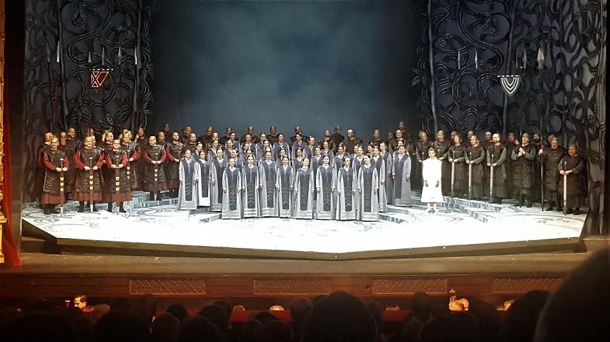

The production was a revival of Wolfgang Wagner’s 1967 Bayreuth production, directed by Katharina Wagner. For me part of the appeal was its simplicity. The set was a few steps with a couch for the wedding night, the swan a lighting effect on the back wall, the costumes looked really good and the overall look was interesting enough without distracting from the music. As usual, the sword fighting choreography owed more to Boris Karloff than to Errol Flynn. I did not expect to be writing about it, so did not take any notes, but nothing stood out as being particularly good. Subtitles were in English which was very helpful. A very pleasant evening was had.

Next morning we made our way to Budapest. Some opted to fly, and a brave few of us decided to take the train. It was a very enjoyable way to travel between the cities, and with such great company, who could want for more? Great food, a few beers, and you could just relax and let the world go by.

This was my third visit to Budapest. I enjoy it more with every visit. On Monday afternoon, we spoke together about what sort of performance this Rienzi would turn out to be. Not many of us in the society had ever seen it before.

This was a concert performance, with a pretty large choir, full orchestra, organ and the singers standing in front. Once again, thanks to Anthony we had fantastic seats, myself being seated in row eight. The performance was four and a half hours long with just one break. Left uncut, I gather the opera is six hours long. Ballet sections were left out. I was struck by the beauty and range of Krisztian Cser in the very small role of Raimondo, his performance far too brief. I look forward to hearing him again. I admit, I was a bit lost as I am not familiar with Rienzi and the surtitles were in German and Hungarian.

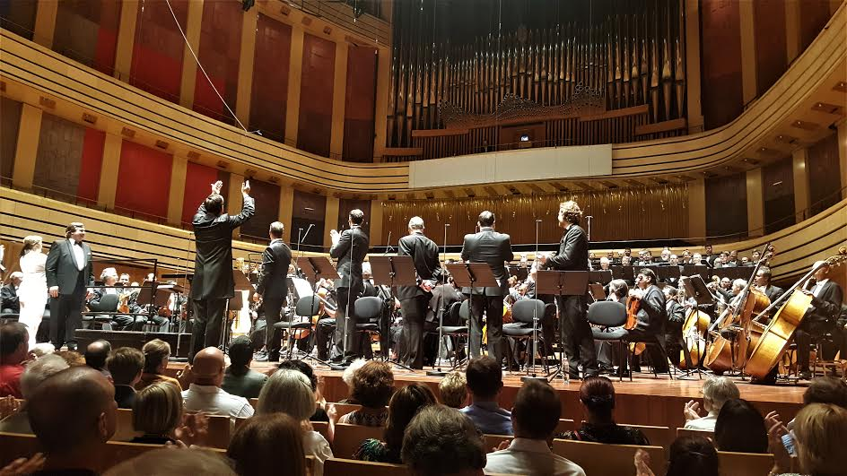

The second half must have been more than two hours yet seemed like twenty minutes. The amalgamation of great singers, orchestra, choir and organ added wonderful colour to the music, The depth to the low notes added by the 32 foot stop was incredible, something we rarely hear (or feel). I think a lot of us now want to see a fully staged version of Rienzi. (The CD has already been purchased).

The Palace of Fine Arts (MUPA) in Budapest is a fantastic venue. Our opera on Wednesday was Parsifal. We were seated at the back wall in row 25, but I do not think that we were at any acoustic disadvantage, every note was clearly heard. The stage was black to begin with and turned white as the performance went on. The men wore tuxedos, completing a monochrome appearance, the one exception being blood running from Amfortas. For a split second I thought there was a drunk being ejected from the audience, but this was Parsifal (The Pure Fool) being dragged through the auditorium to be brought before Gurnemanz. Later, the knights marched through the audience from the back doors to converge on the stage in what was a pleasant effect. In the final act, the knights converged onstage again, joined by the choir, filling the balcony around the organ to great effect. There were three members of the Vienna Boys Choir in the production. The choir was excellent. Peter Seiffert sang the title role and all the singers were decent. My standout favourite was Albert Posendorfer as Gurnemanz.

On Thursday we made our way back to Dublin. Along the way I thought to myself, was that trip really six days long?

Tempus fugit! Roll on November.

BRIAN COFFEY

(Thanks to Louise for translating my scribbles into English.)

